UOW-logo

**Informatics Institute of Technology**

Department of Computing

ECSC410: Software Development Principles 01

Module Leaders: Mr. Guganathan Poravi

Mrs. Aloka Fernando

Date of Submission: 14th of Dec 2015

Student Name: Pasindu Purna Uduwila Arachchi

Student ID: 2014038

UOW ID :15830463

**Table of contents**

Contents

**No table of contents entries found.**

1. Acknowledgement…………………………………………………………………...03
2. Introduction………………………………………………………………………….03
3. Design………………………………………………………………………………...04
4. Pseudo Codes………………………………………………………………………...06
5. Source Code…………………………………………………………………………08
6. Screen Shots…………………………………………………………………………10
   * 1. *Screenshot 1.1……………………………………………………………….*10
     2. *Screenshot 1.2……………………………………………………………….*10
     3. *Screenshot 1.3……………………………………………………………….*11
     4. *Screenshot 1.4……………………………………………………………….*11
     5. *Screenshot 1.5……………………………………………………………….*12
     6. *Screenshot 1.6……………………………………………………………….*12
7. Conclusion……………………………………………………………………………13

**Acknowledgement**

I like to thank our Software Development Principles module leaders, Mr. Guganathan Poravi, Mrs. Aloka Fernando for providing us with the knowledge and guiding us through; to complete this project. We can say firmly with zero doubt that this project has immensely helped us to improve our knowledge regarding the subject.

**Introduction**

This project called Hangman game. There will be a program to guess a word. User needs to guess a letter by letter. If the guess is correct game will continue. If the guess is incorrect hangman image will be shown part by part. Very firstly I designed flowcharts and pseudo codes to meet the given requirements. Then tested the coding.

This project was done by Pasindu Purna Uduwila Arachchi (2014038)

**Design**

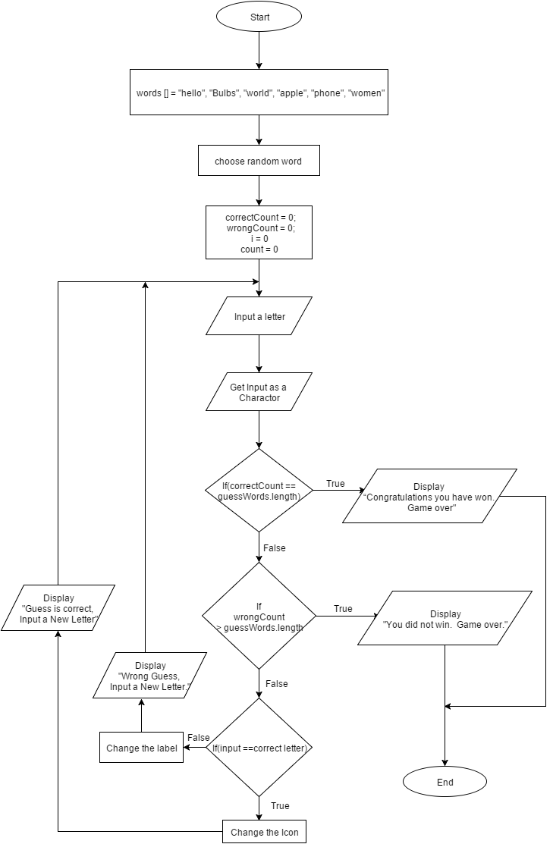

**Pseudo Codes**

WordGameApplication

Set words [] = “hello”,”bulbs”,”world”,”apple”,”phone”,”women”

Set correctcount = 0

Set wrongcount = 0

Get random word

Prompt for a letter

Set char[] value = new char[5]

Set i = 0

While(i < guessWords.length) do

value = guessWords

End While

Set count = 0

Get Input from textInput

While(i < guessWords.length) do

(value[i] = guessWords.charAt(i))

IF (input == value[i])Then

Switch

Case 0 : Display input in labelOne

Case 1 : Display input in labelTwo

Case 2 : Display input in labelThree

Case 3 : Display input in labelFour

Case 4 : Display input in labelFive

ELSE

count++

END IF

End While

IF(count == guessWords.length)Then

Display wrongcount in lablelcount

Display “Wrong Guess, Input a New Letter” in textMessage

ELSE

Display “Guess is correct, Input a New Letter” in textMessage

END IF

IF(correctCount == guessWords.length)Then

Display “Congratulations you have won.  Game over” in textMessage

END IF

IF (wrongCount == 1)Then

Set icon of btnHangman to hangMan-01

ELSEIF (wrongCount == 2)Then

Set icon of btnHangman to hangMan-02

ELSEIF (wrongCount == 3)Then

Set icon of btnHangman to hangMan-03

ELSEIF (wrongCount == 4)Then

Set icon of btnHangman to hangMan-04

ELSEIF (wrongCount == 5)Then

Set icon of btnHangman to hangMan-05

ELSEIF (wrongCount == 6)Then

Set icon of btnHangman to hangMan-06

Display “You did not win.  Game over.” in textMessage

ENDIF

ENDIF

ENDIF

ENDIF

ENDIF

**Source Code**

/**

*

* @author Pasindu Purna

*/

String[] words = {"hello", "bulbs", "world", "apple", "phone", "women"};

int random = (int) (Math.random() * 6);

public int correctCount = 0;

public int wrongCount = 0;

public String guessWords = words[random];

private void btnTryActionPerformed(java.awt.event.ActionEvent evt) {

// TODO add your handling code here:

char[] value = new char[5]; //creating a char array

for (int i = 0; i < guessWords.length(); i++) {

value[i] = guessWords.charAt(i);

}

try{

char input = txtInput.getText().toLowerCase().charAt(0); //Converting the input to lowercase

int count = 0;

//Using a for loop linear search of the words to guess

for (int i = 0; i < guessWords.length(); i++) {

if (input == value[i]) {

//switch case

switch (i) {

case 0:

lblOne.setText(input + "");

break;

case 1:

lblTwo.setText(input + "");

break;

case 2:

lblThree.setText(input + "");

break;

case 3:

lblFour.setText(input + "");

break;

case 4:

lblFive.setText(input + "");

break;

}

correctCount++; //Incrementing

} else {

count++;

}

if (count == guessWords.length()) {

count = 0;

wrongCount++;

lblCount.setText(wrongCount + "");

txtMessage.setText("Wrong Guess, Input a New Letter");

}else{

txtMessage.setText("Guess is correct, Input a New Letter");

}

if (correctCount == guessWords.length()) {

txtMessage.setText("Congratulations you have won. Game over");

}

}

txtInput.setText("");

} catch (Exception e) {

txtMessage.setText("Input a Letter");

}

//Set ImageIcon

if (wrongCount == 1) {

btnHangman.setIcon(new javax.swing.ImageIcon(getClass().getResource("/Project_01/HangMan-01.jpg")));

} else if (wrongCount == 2) {

btnHangman.setIcon(new javax.swing.ImageIcon(getClass().getResource("/Project_01/HangMan-02.jpg")));

} else if (wrongCount == 3) {

btnHangman.setIcon(new javax.swing.ImageIcon(getClass().getResource("/Project_01/HangMan-03.jpg")));

} else if (wrongCount == 4) {

btnHangman.setIcon(new javax.swing.ImageIcon(getClass().getResource("/Project_01/HangMan-04.jpg")));

} else if (wrongCount == 5) {

btnHangman.setIcon(new javax.swing.ImageIcon(getClass().getResource("/Project_01/HangMan-05.jpg")));

} else if (wrongCount == 6) {

txtMessage.setText("You did not win. Game over.");

btnHangman.setIcon(new javax.swing.ImageIcon(getClass().getResource("/Project_01/HangMan-06.jpg")));

}

}

**Screen Shots**

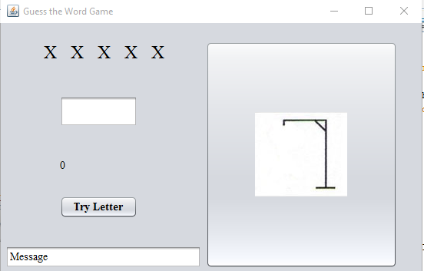

*Screenshot 1.1*

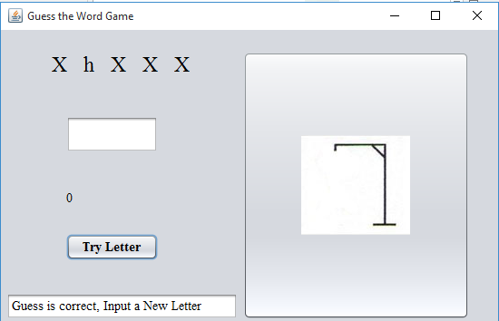

*Screenshot 1.2*

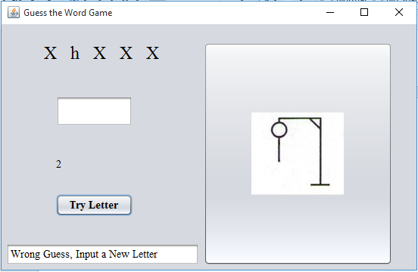

*Screenshot 1.3*

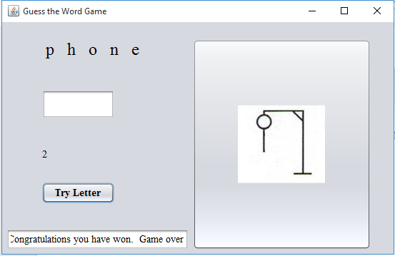

*Screenshot 1.4*

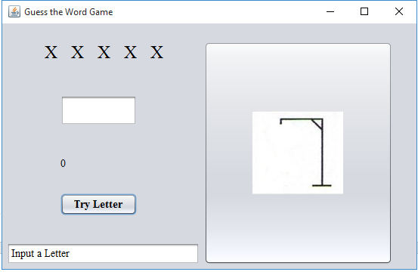

*Screenshot 1.5*

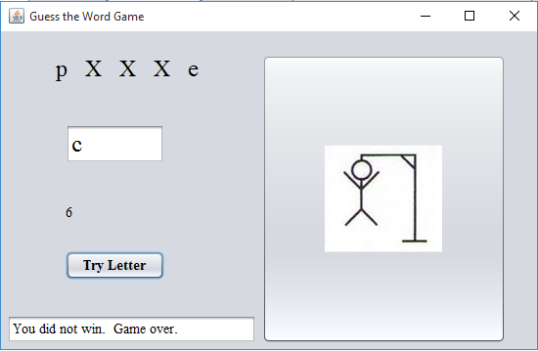

*Screenshot 1.6*

**Conclusion**

This project has given us the knowledge in how to implement some of the basic functions in the Java language and also has taught us how to analyze a given specification, design GUI, drawing flow charts, build pseudo code, code a program in advance, test a program & fix bugs.

As well as after doing this it increased our knowledge to how to work on Netbeans, our logical thinking & improved our technical skills.